**LAKIREDDY BALI REDDY COLLEGE OF ENGINEERING (Autonomous)**

L.B. Reddy Nagar, Mylavaram-521 230. Andhra Pradesh, INDIA

Affiliated to JNTUK, Kakinada & Approved by AICTE New Delhi

Accredited by NBA, New Delhi & Certified by ISO 9001:2015, http://www.lbrce.ac.in

**DEPARTMENT OF ELECTRICAL & ELECTRONICS ENGINEERING**

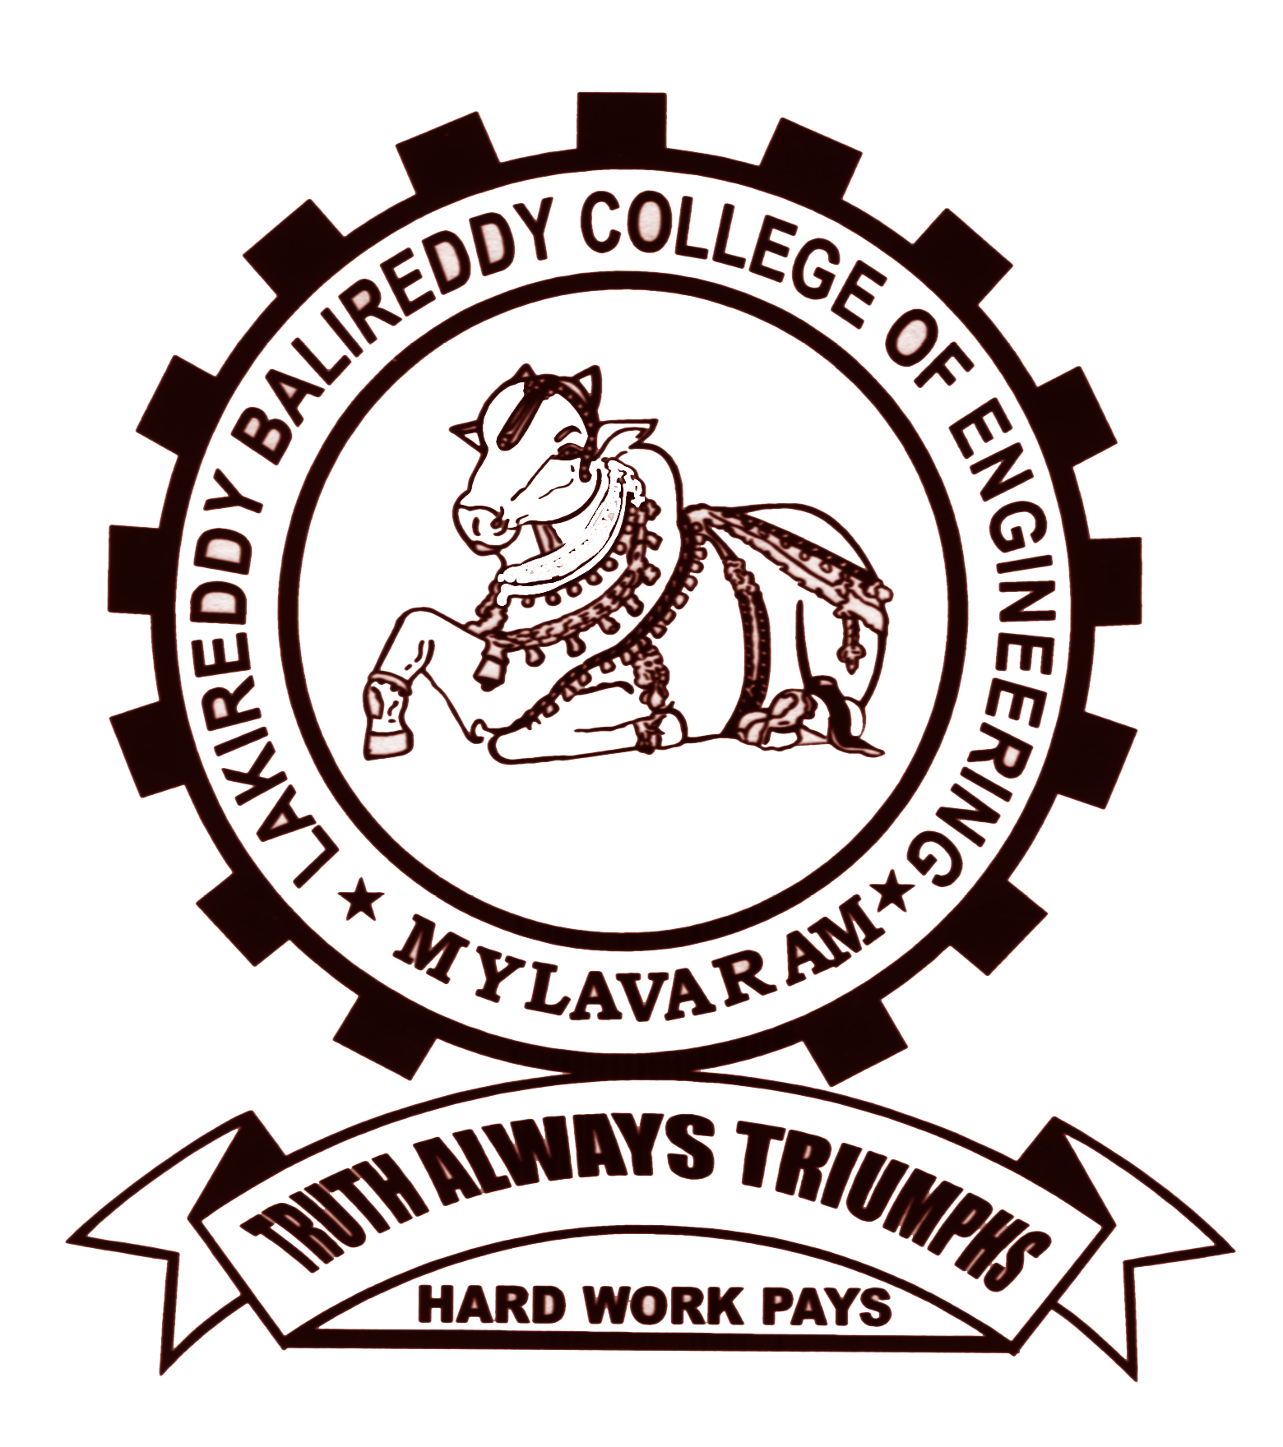

Course: B.Tech Semester: I Code: **20EE01** A.Y: 2023-24

Course Title: Basic Electrical & Electronics Engineering Branch: AI&DS

**UNIT-II: DESCRIPTIVE QUESTIONS**

1. Explain the construction details and working of a DC generator.
2. Illustrate the principle of operation and construction of DC motor with a neat diagram.
3. Illustrate the principle of operation and the various parts of a Single-phase transformer with a neat diagram.
4. Explain the principle of operation and constructional details of a three phase induction motor.
5. Describe the principle of operation and the various parts of 3-phase alternator with the help of neat sketches.
6. Describe the working principle of transformer, what are the different types of transformer?
7. Discuss the working and the various parts in PMMC instruments.
8. Illustrate the working and the various parts in MI instruments.
9. What is the Wheatstone Bridge principle? And explain the construction of Wheatstone bridge.

|  |  |  |  |
| --- | --- | --- | --- |
|  |  |  |  |
| COURSE INSTRUCTOR | COURSE COORDINATOR | MODULE COORDINATOR | HOD |
| Dr.AVGA.Marthanda | Dr.AVGA.Marthanda | DR. G.NAGESWARA RAO | DR. J. S. V. PRASAD |